SECTOR AREAS AND ARC LENGTH
Pearson Edexcel – Thursday 4 June 2020 - Paper 2 (Calculator) Higher Tier
1.
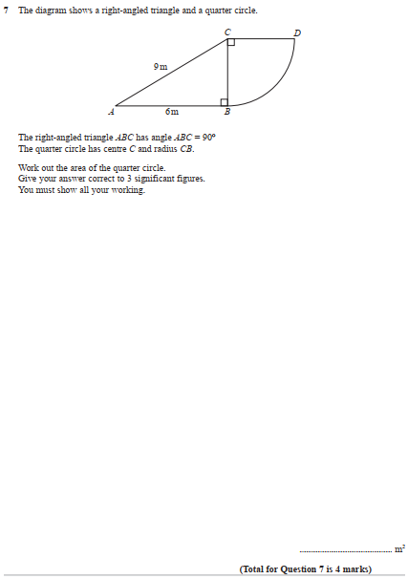

Pearson Edexcel – Thursday 4 June 2020 - Paper 2 (Calculator) Higher Tier
2.
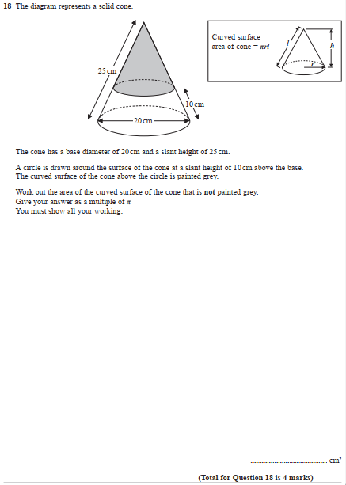

Pearson Edexcel – Monday 8 June 2020 - Paper 3 (Calculator) Higher Tier
3.
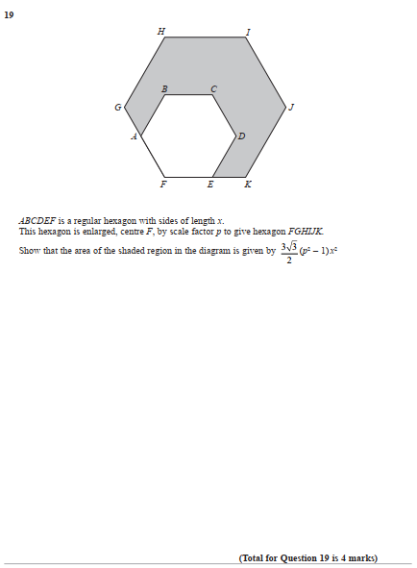

Pearson Edexcel - Thursday 6 June 2019 - Paper 2 (Calculator) Higher Tier
4.
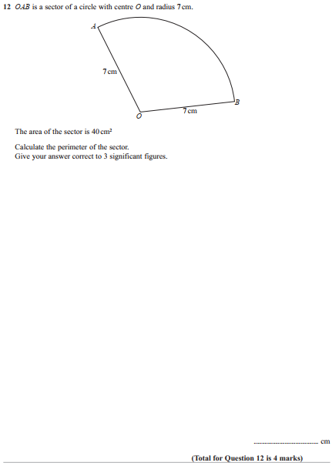
Pearson Edexcel - Tuesday 6 November 2018 - Paper 1 (Non-Calculator) Higher Tier
5.
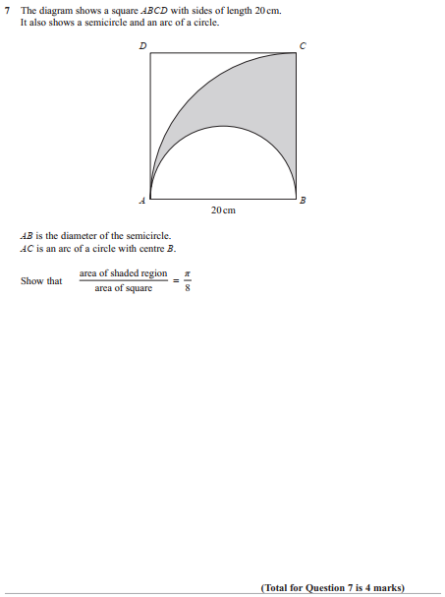

Pearson Edexcel - Thursday 2 November 2017 - Paper 1 (Non-Calculator) Higher Tier
6.
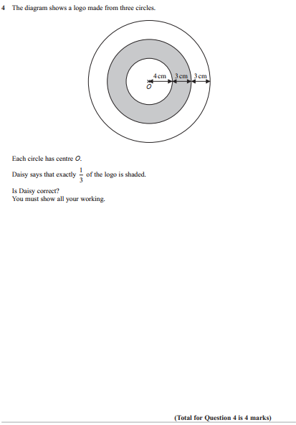

Pearson Edexcel - Monday 6 November 2017 - Paper 2 (Calculator) Higher Tier
7.
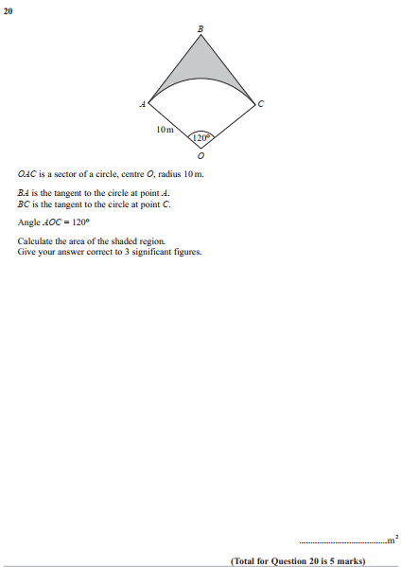

Pearson Edexcel - Thursday 8 June 2017 - Paper 2 (Calculator) Higher Tier
8.
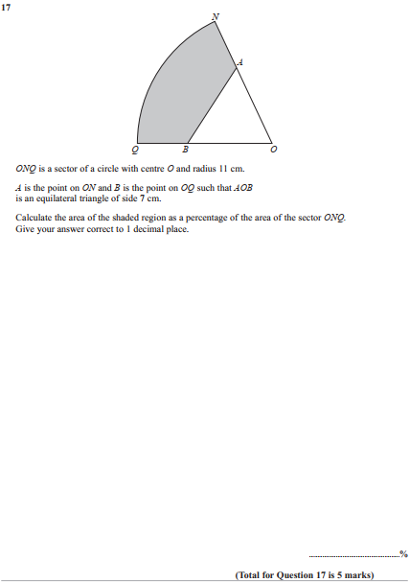

Pearson Edexcel - Tuesday 13 June 2017 - Paper 3 (Calculator) Higher Tier
9.
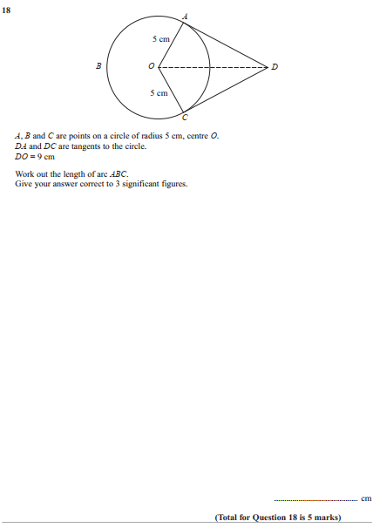

Pearson Edexcel - Specimen Papers Set 2 - Paper 1 (Non-Calculator) Higher Tier
10.
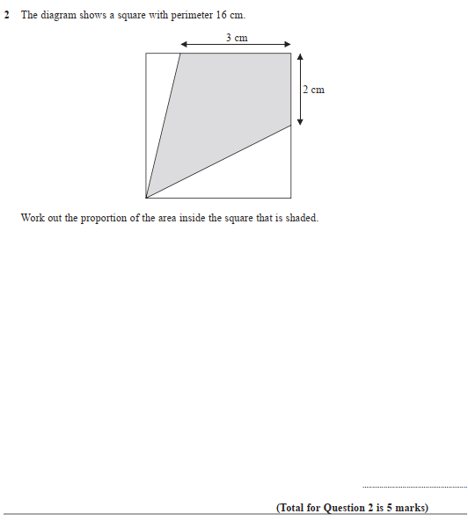

Pearson Edexcel - Specimen Papers Set 2 - Paper 2 (Calculator) Higher Tier
11.
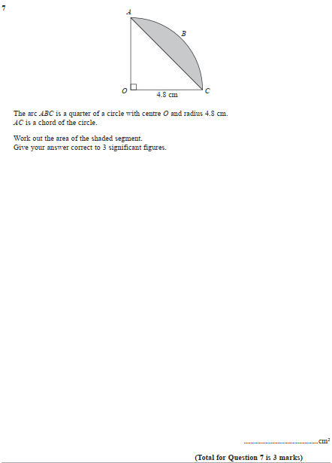

Pearson Edexcel - Specimen Papers Set 2 - Paper 3 (Calculator) Higher Tier
12.
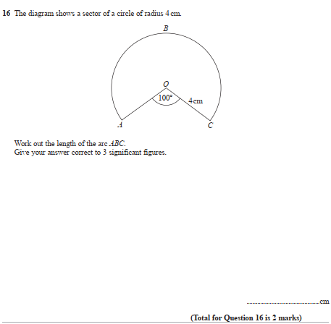

Pearson Edexcel - Sample Paper 2 - (Calculator) Higher Tier
13.
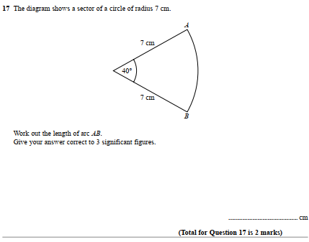

Pearson Edexcel - Sample Paper 3 - (Calculator) Higher Tier
14.
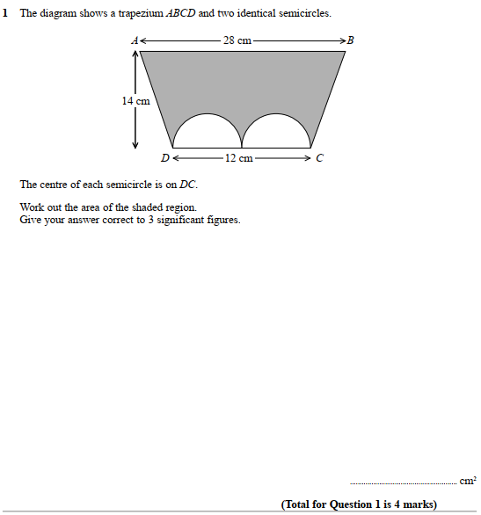

Pearson Edexcel - Thursday 26 May 2016 - Paper 1 (Non-Calculator) Higher Tier
15.
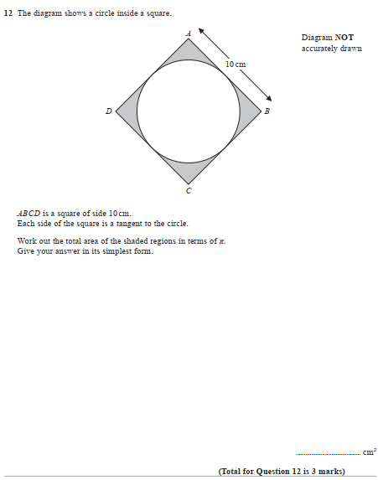

Pearson Edexcel - Thursday 26 May 2016 - Paper 1 (Non-Calculator) Higher Tier
16.
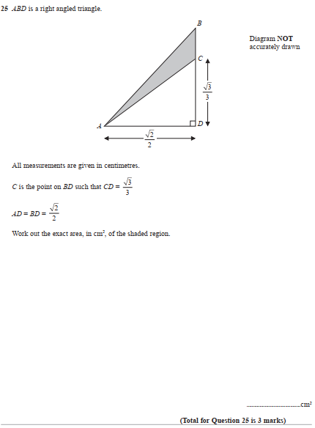

Pearson Edexcel - Wednesday 5 November 2014 - Paper 1 (Non-Calculator) Higher Tier
17.
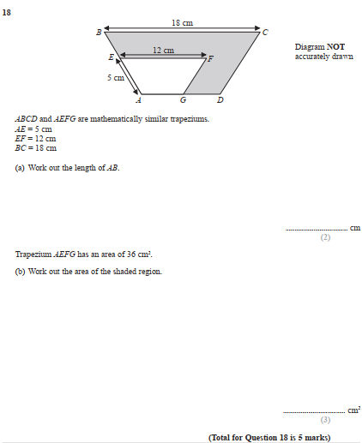

Pearson Edexcel - Monday 4 March 2013 - Paper 2 (Calculator) Higher Tier
18.
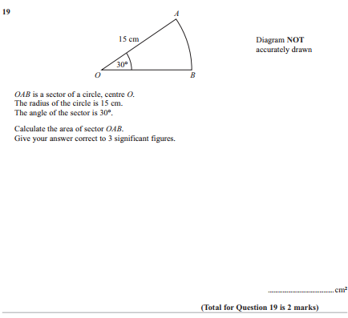

Pearson Edexcel - Tuesday 6 November 2012 - Paper 1 (Non-Calculator) Higher Tier
19.
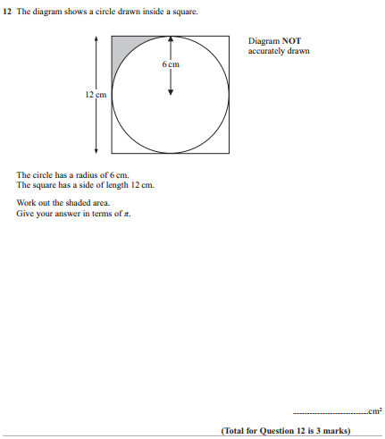

Pearson Edexcel - Friday 2 March 2012 - Paper 3 (Non-Calculator) Higher Tier
20.
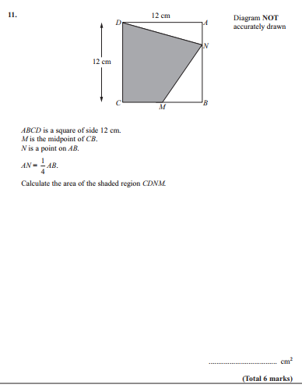

Pearson Edexcel - Monday 5 March 2012 - Paper 4 (Calculator) Higher Tier
21.
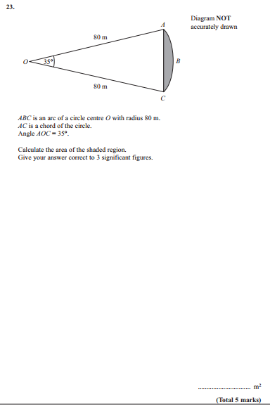

Pearson Edexcel - Friday 10 June 2011 - Paper 4 (Calculator) Higher Tier
22.
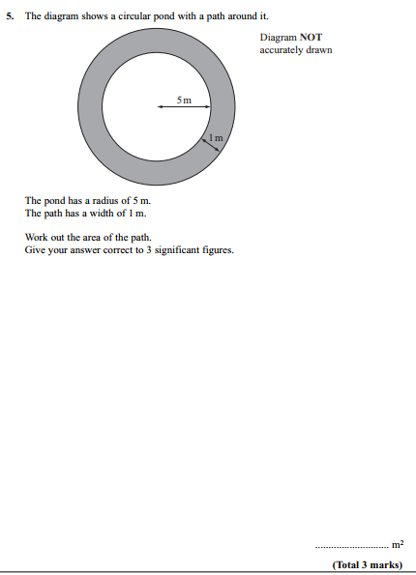

Pearson Edexcel - Friday 11 June 2010 - Paper 4 (Calculator) Higher Tier
23.
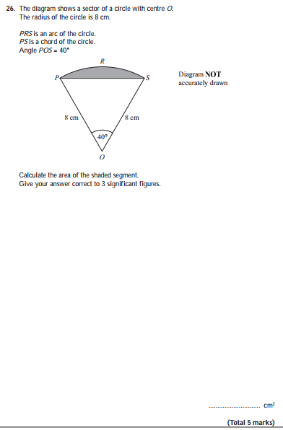
OCR GSCE – Thursday 6 June 2019 – Paper 5 (Non-Calculator) Higher Tier
24.

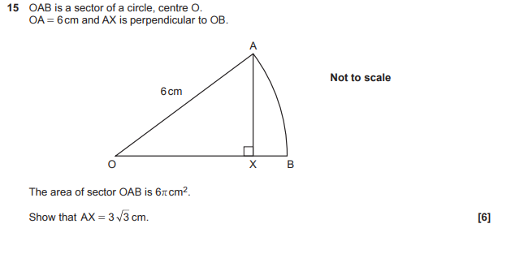

OCR GSCE – Thursday 8 November 2018 – Paper 5 (Non-Calculator) Higher Tier
25.
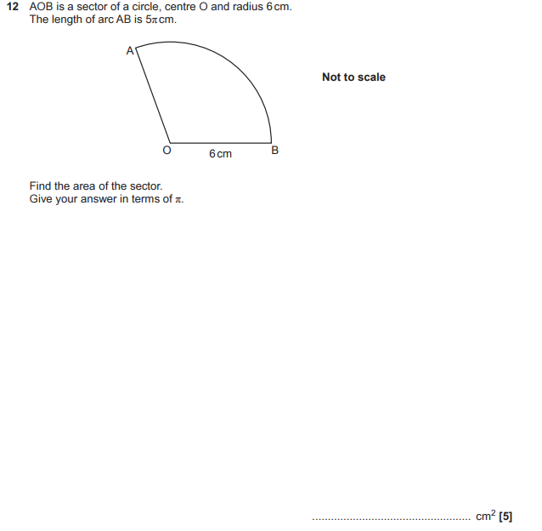

OCR GSCE – Tuesday 6 November 2017 – Paper 5 (Non - Calculator) Higher Tier
26.
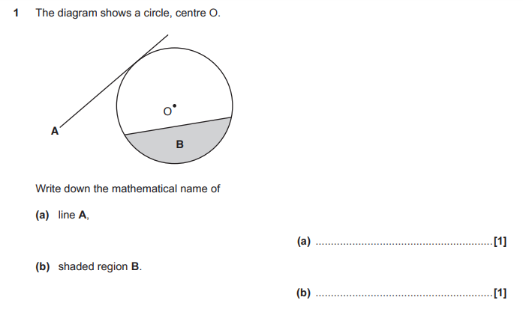

OCR GSCE – Wednesday 8 November 2017 – Paper 6 (Calculator) Higher Tier
27.
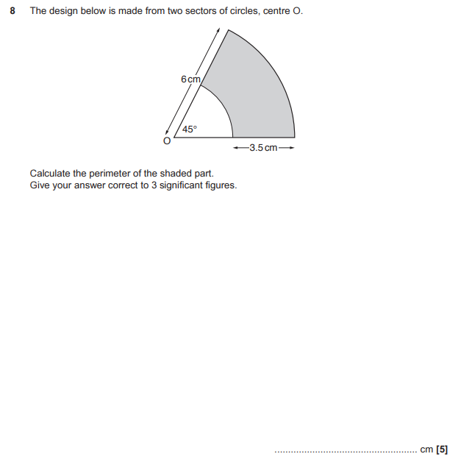

AQA GSCE – Tuesday 11 June 2019 – Paper 3 (Calculator) Higher Tier
28.
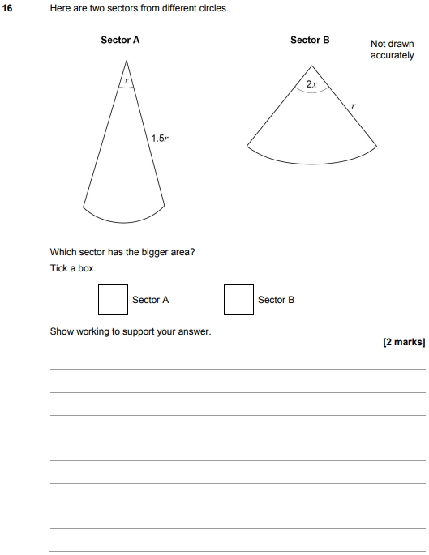

AQA GSCE – Thursday 2 November 2017 – Paper 1 (Non - Calculator) Higher Tier
29.
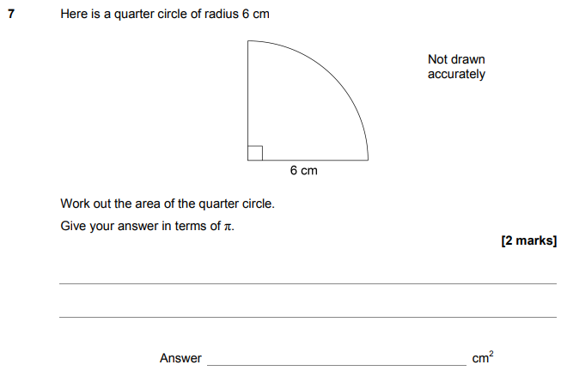

AQA GSCE – Thursday 6 November 2017 – Paper 2 (Calculator) Higher Tier
30.
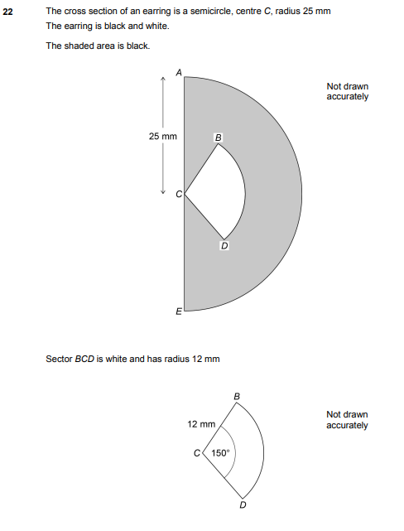
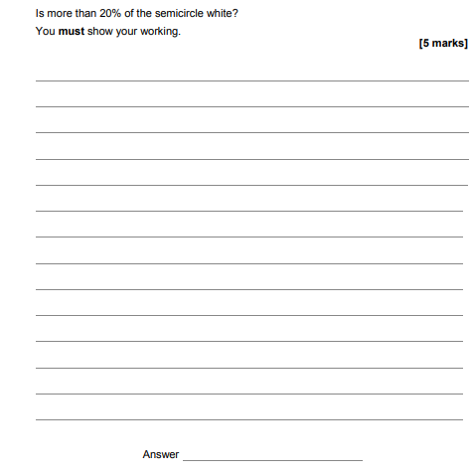

AQA GSCE – Thursday 8 June 2017 – Paper 2 (Calculator) Higher Tier
31.
